**GitHub Copilot request process**

**Guideline**

|  |  |  |
| --- | --- | --- |
| Version id | Date | Changes |
| Version – 0.1 | 31-Oct-2023 | First draft |
| Version – 1.0 | 1-Nov-2023 | Added the GitHub Copilot License fee details |
| Version – 1.1 | 3-Nov-2023 | Added the ADM Process |

Contents

GithubCopilot Servicenow request process 3

3 Step Process to get GitHub Copilot 3

**Step 1- Workflow to procure approval** 4

**Step 2 : ServiceNow Request** 5

**Step 3 : Activate** **GitHub Copilot** 6

**GitHub Copilot License fee** 8

**Training Video links** 9

# GithubCopilot Servicenow request process

## 3 Step Process to get GitHub Copilot

* Step 1 – Obtain approval from ADM GenAI Practice Approver
* Refer below for the Workflow , Mail template , SBU Champions and GenAI Practice Approver Contacts for ADM.
* Step 2 – Raise ServiceNow request.
* Step 3- Activate GitHub Copilot.

## **Step 1- Workflow to procure approval**

Follow the Workflow and Mail Template provided below to procure approval from GenAI Practice Approver.

**Workflow** à Associate sends the request to PM 🡪 PMs to review and approve 🡪 PMs to send to Gen AI Champ 🡪 GenAI Champ to review and approve 🡪 GenAI champ to send GenAI Practice Approver (Refer GenAI Practice Approvers Table). 🡪 GenAI Practice Approver to review and approve 🡪 GenAI Champ sends the approval to associate 🡪 Associate attaches approval mail from Practice approver to the ServiceNow ticket.

*Mail Template*



**ADM GenAI Champs**

|  |  |  |
| --- | --- | --- |
| **SBU** | **GenAI Champion Name** | **GenAI Champion ID** |
| GGM(APAC/CE/UK) | Bhushan, Vikas | 325568 |
| BFS-NA | Seshadrinathan, Ramasubramanian | 127647 |
| CMT-NA | Natarajan, Karthik | 106570 |
| HC-NA | Chinnusamy, Senthilkumar | 104295 |
| INS-NA | Royar, Jerald | 105716 |
| LS-NA | Kuppusamy, Thiyagarajan | 359167 |
| MLEU-NA | Bhattacharjee, Bhaskar | 111309 |
| RCGTH-NA | Maharana, Girija | 106488 |

**GenAI Practice Approvers**

|  |  |  |
| --- | --- | --- |
| **SBU** | **Approver Name** | **Approver ID** |
| GGM(APAC/CE/UK) | Patwardhan, Shashank | 497763 |
| Banking & Insurance | Chidambaram, Subramaniam | 107557 |
| P&R, HS and CMT | Chinnaswamy, Amudha | 102681 |

## **Step 2 : ServiceNow Request**

1. Login into Service now

[**https://ctsccprod.service-now.com/ss?id=ss_home_page_servicenow**](https://ctsccprod.service-now.com/ss?id=ss_home_page_servicenow)

Search as “Request Software asset”

1. Fill all the mandatory fields and ensure the **below 3 fields** are filled in appropriately.
2. Software model 🡪Search as *\*GitHub Copilot*.
3. Business Justification 🡪 Enter your Service Line you are part of e.g., ADM/QEA/AIA/IT.
4. Add Attachments 🡪 Attach Approval email from the respective Service Line approvers. Refer to the above table for Service Line approvers.

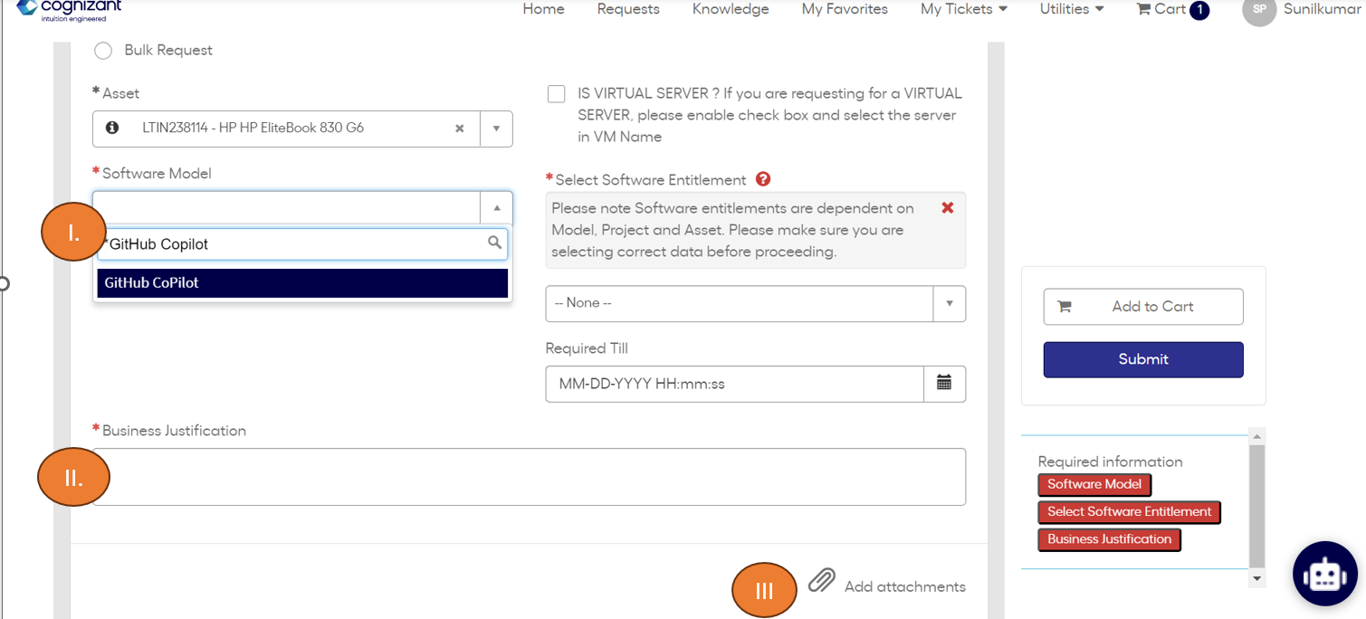

Once the request is raised, IT will take 1 business day (24 hours) to fulfill the request.

## **Step 3 : Activate** **GitHub Copilot**

1. Login into the Url [https://github.com/enterprises/CognizantGitHubCopilot](https://github.com/enterprises/CognizantGitHubCoPilot)

Once access has been granted, you will see the above screen with “continue” button.

**2**: Click on Continue

You will be redirect to the below screen.

**3**: Open Visual Studio Enterprise/Professional or VS Code and make sure GitHub is connected with your Cognizant AssociateId to enable the Copilot license. Please avoid connecting GitHub with your personal or any other email IDs.

Refer the supported IDE for Copilot - [Configuring GitHub Copilot in your environment - GitHub Docs](https://docs.github.com/en/copilot/configuring-github-copilot/configuring-github-copilot-in-your-environment)

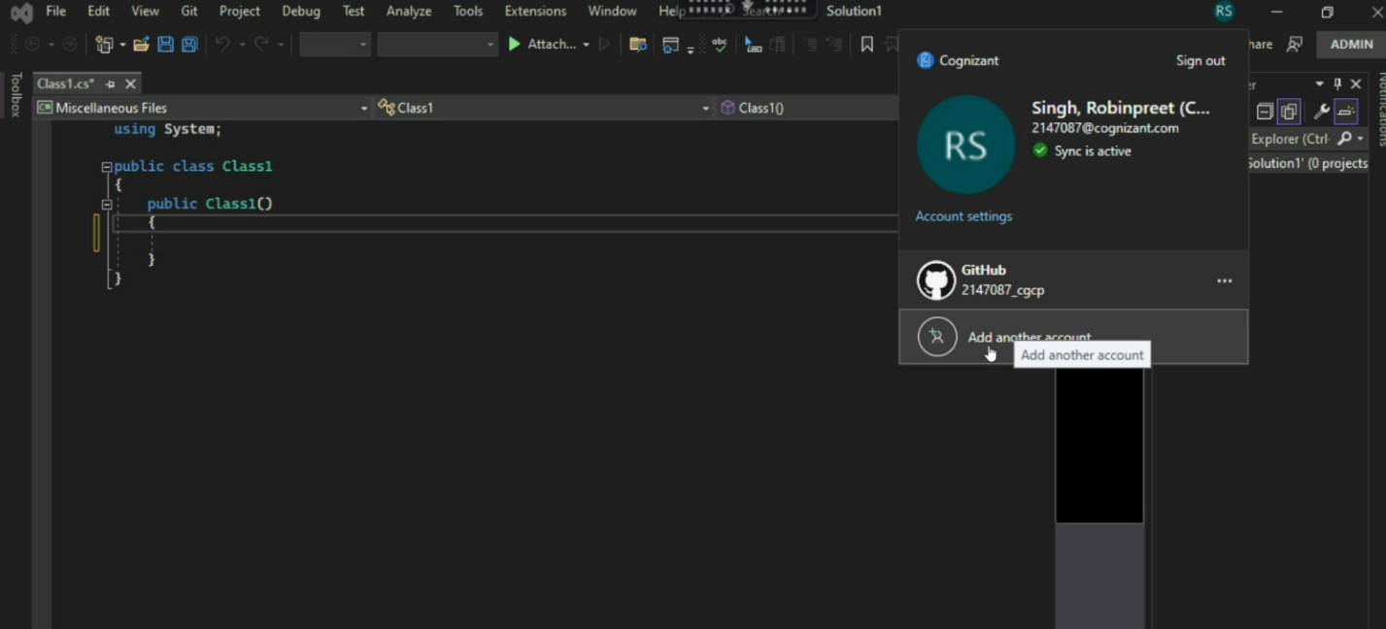

## **GitHub Copilot License fee**

According to Microsoft's official licensing policy, a GitHub license is required to access GitHub CoPilot, which means the regular price is about $20 (GitHub) + $20 (GitHub CoPilot) = $40/Associate/Month. However, until June 2024, Microsoft has offered a special deal that waives the GitHub license fee and reduces the GitHub CoPilot fee, so the current price is only $14/Associate/Month. After June 2024, Microsoft may decide to reinstate the GitHub license fee, which would increase the cost of using GitHub CoPilot.

## **Training Video links**

1. GitHub Copilot – K-point session

[https://cognizant.kpoint.com/web/videos/gcc-6fe8aaf5-6b28-46d0-805b-56ce8da1c0d1](https://apc01.safelinks.protection.outlook.com/?url=https%3A%2F%2Fcognizant.kpoint.com%2Fweb%2Fvideos%2Fgcc-6fe8aaf5-6b28-46d0-805b-56ce8da1c0d1&data=05%7C01%7CSunilkumar.P%40cognizant.com%7C9e0babc9acdc40e27eb008dbd62da57e%7Cde08c40719b9427d9fe8edf254300ca7%7C0%7C0%7C638339263759061599%7CUnknown%7CTWFpbGZsb3d8eyJWIjoiMC4wLjAwMDAiLCJQIjoiV2luMzIiLCJBTiI6Ik1haWwiLCJXVCI6Mn0%3D%7C3000%7C%7C%7C&sdata=bNij2z%2FHtYKQC20kHgJ%2Fu62NwFP3FshH1EIWMvrX4tM%3D&reserved=0)

1. Introduction to GitHub (learning + knowledge check)

[Introduction to GitHub Copilot - Training | Microsoft Learn](https://apc01.safelinks.protection.outlook.com/?url=https%3A%2F%2Flearn.microsoft.com%2Fen-us%2Ftraining%2Fmodules%2Fintroduction-to-github-copilot%2F&data=05%7C01%7CSunilkumar.P%40cognizant.com%7C9e0babc9acdc40e27eb008dbd62da57e%7Cde08c40719b9427d9fe8edf254300ca7%7C0%7C0%7C638339263759061599%7CUnknown%7CTWFpbGZsb3d8eyJWIjoiMC4wLjAwMDAiLCJQIjoiV2luMzIiLCJBTiI6Ik1haWwiLCJXVCI6Mn0%3D%7C3000%7C%7C%7C&sdata=xlpsxPFYdhZY%2BYaOLz7y11V%2BsNuuPXIz9TdBGhPMrkM%3D&reserved=0)

1. GitHub Copilot -Visual Studio Toolbox

[Github Copilot | Microsoft Learn](https://apc01.safelinks.protection.outlook.com/?url=https%3A%2F%2Flearn.microsoft.com%2Fen-us%2Fshows%2Fvisual-studio-toolbox%2Fgithub-copilot&data=05%7C01%7CSunilkumar.P%40cognizant.com%7C9e0babc9acdc40e27eb008dbd62da57e%7Cde08c40719b9427d9fe8edf254300ca7%7C0%7C0%7C638339263759061599%7CUnknown%7CTWFpbGZsb3d8eyJWIjoiMC4wLjAwMDAiLCJQIjoiV2luMzIiLCJBTiI6Ik1haWwiLCJXVCI6Mn0%3D%7C3000%7C%7C%7C&sdata=%2F%2BE9zE%2FD%2BHRxDfsZLzEP9fKUXk%2F44qwytj4zUV%2Bn%2Fvs%3D&reserved=0)

1. GitHub Copilot Series - YouTube

<https://www.youtube.com/playlist?list=PLj6YeMhvp2S5_hvBl2SE-7YCHYlLQ0bPt>